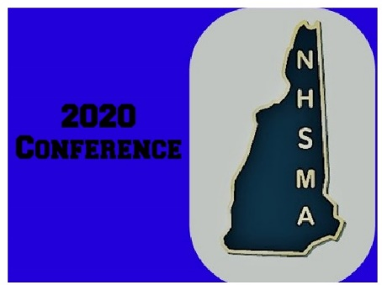
NHSMA Spring Conference Mail In Registration Form
Conference will be held at the HOLIDAY INN in Concord NH on Oct. 16 and 17.
Please complete this registration form and mail it, along with payment, to:
NHSMA Treasurer 5 Reubens Driftway Hampton NH 03842

Date |  | Which days will you be attending? (Fri, Sat, or BOTH?)
First Name |  |  |  |  |  |  | Last Name
Cost for Conference - Early Bird pricing: $80 for an individual day, $150 for both days
Home Phone |  |  |  | Cell Phone |  |  |  |  | Email Address
Address
City |  |  |  |  | State. |  |  |  |  | ZIP Code
**Credential (ex: CMA, CCMA, RMA, other,etc?) - If you are not credentialed please write NONE.
Are you a member of the NHSMA (AAMA)? |  |  |  |  |  |  | NHSMA (AAMA) Membership number
Please list any food allergies here:

**Please note, regarding the credentialing question: Since the NHSMA welcomes ALL Medical Assistants it is helpful for us to get a sense of how many of our members have different credentials. We want to advocate for all of you so we want to be sure we are speaking to the right organizations. Below is a list of the 3 most common organizations in the state and what credentials they offer.
Registered Medical Assistant (RMA) Credential is through the American Medical Technologists (AMT)
​Certified Clinical Medical Assistant (CCMA) Credential is through the National Healthcare Association (NHA)​
Certified Medical Assistant (CMA) Credential is through the American Association of Medical Assistants (AAMA)

