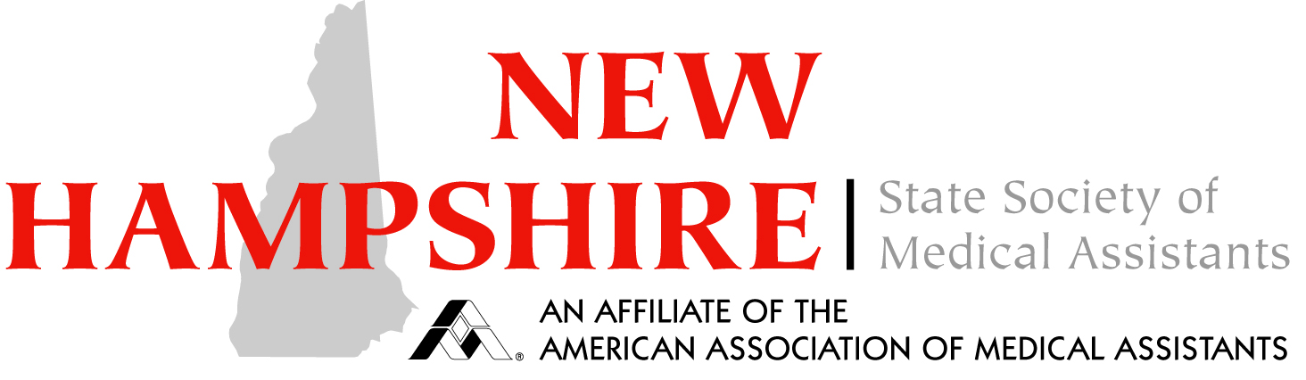

Dear Member,

Welcome to the 2018/ 2019 planning year of the New Hampshire State Society of Medical Assistants. We have had a great couple of years and the current board will strive to exceed the accomplishments of the past years. The success of the CEU sessions, in co-operation with Exeter Hospital/ Core Physicians and Concord Hospital and the increased communications with other employers in New Hampshire, have high-lighted the importance of Medical Assisting in New Hampshire. This culminated in the presentation of the first ever NHSMA STAR Award to Exeter Hospital/ Core Physicians for their support of the CEU Sessions.
One of the innovations NHSMA has brought to the American Association of Medical Assistants is our Ambassador Program. Our Ambassadors are the point person for the region in which they serve. Although we are a small state, each region has it’s own flavor, unique issues and needs. The Ambassadors work hand in hand with the Executive Board to bring issues to the board’s attention as well as helping to plan CEU sessions and Community Relation Projects in their area.
I would like to invite you to consider becoming an Ambassador for the NHSMA.
The Board will help by providing you with a mentor and open communication with our Ambassadors. We ask that you participate in as many board meetings as you can. This can be done in person, electronically or by phone. We are a very flexible and informal group. Ideas flow easily and are always encouraged.
If you have questions and would like more information, please contact me or any other board member. We would love to hear from you. If fact, if you have an idea to share or a question, we are always happy to hear from our members. All members are invited to the board meetings. Don’t forget to check out our website: NHSMA.org and the NHSMA Facebook page.
Thank-you for the job that you do. You are the face of the NHSMA to the public and to employers. Keep up the good work!
Linda Prince, CMA (AAMA), COA, OCT-C
President
NHSMA
IMPastPresident@yahoo.com
603-421-4540
7/30/18 ljp

